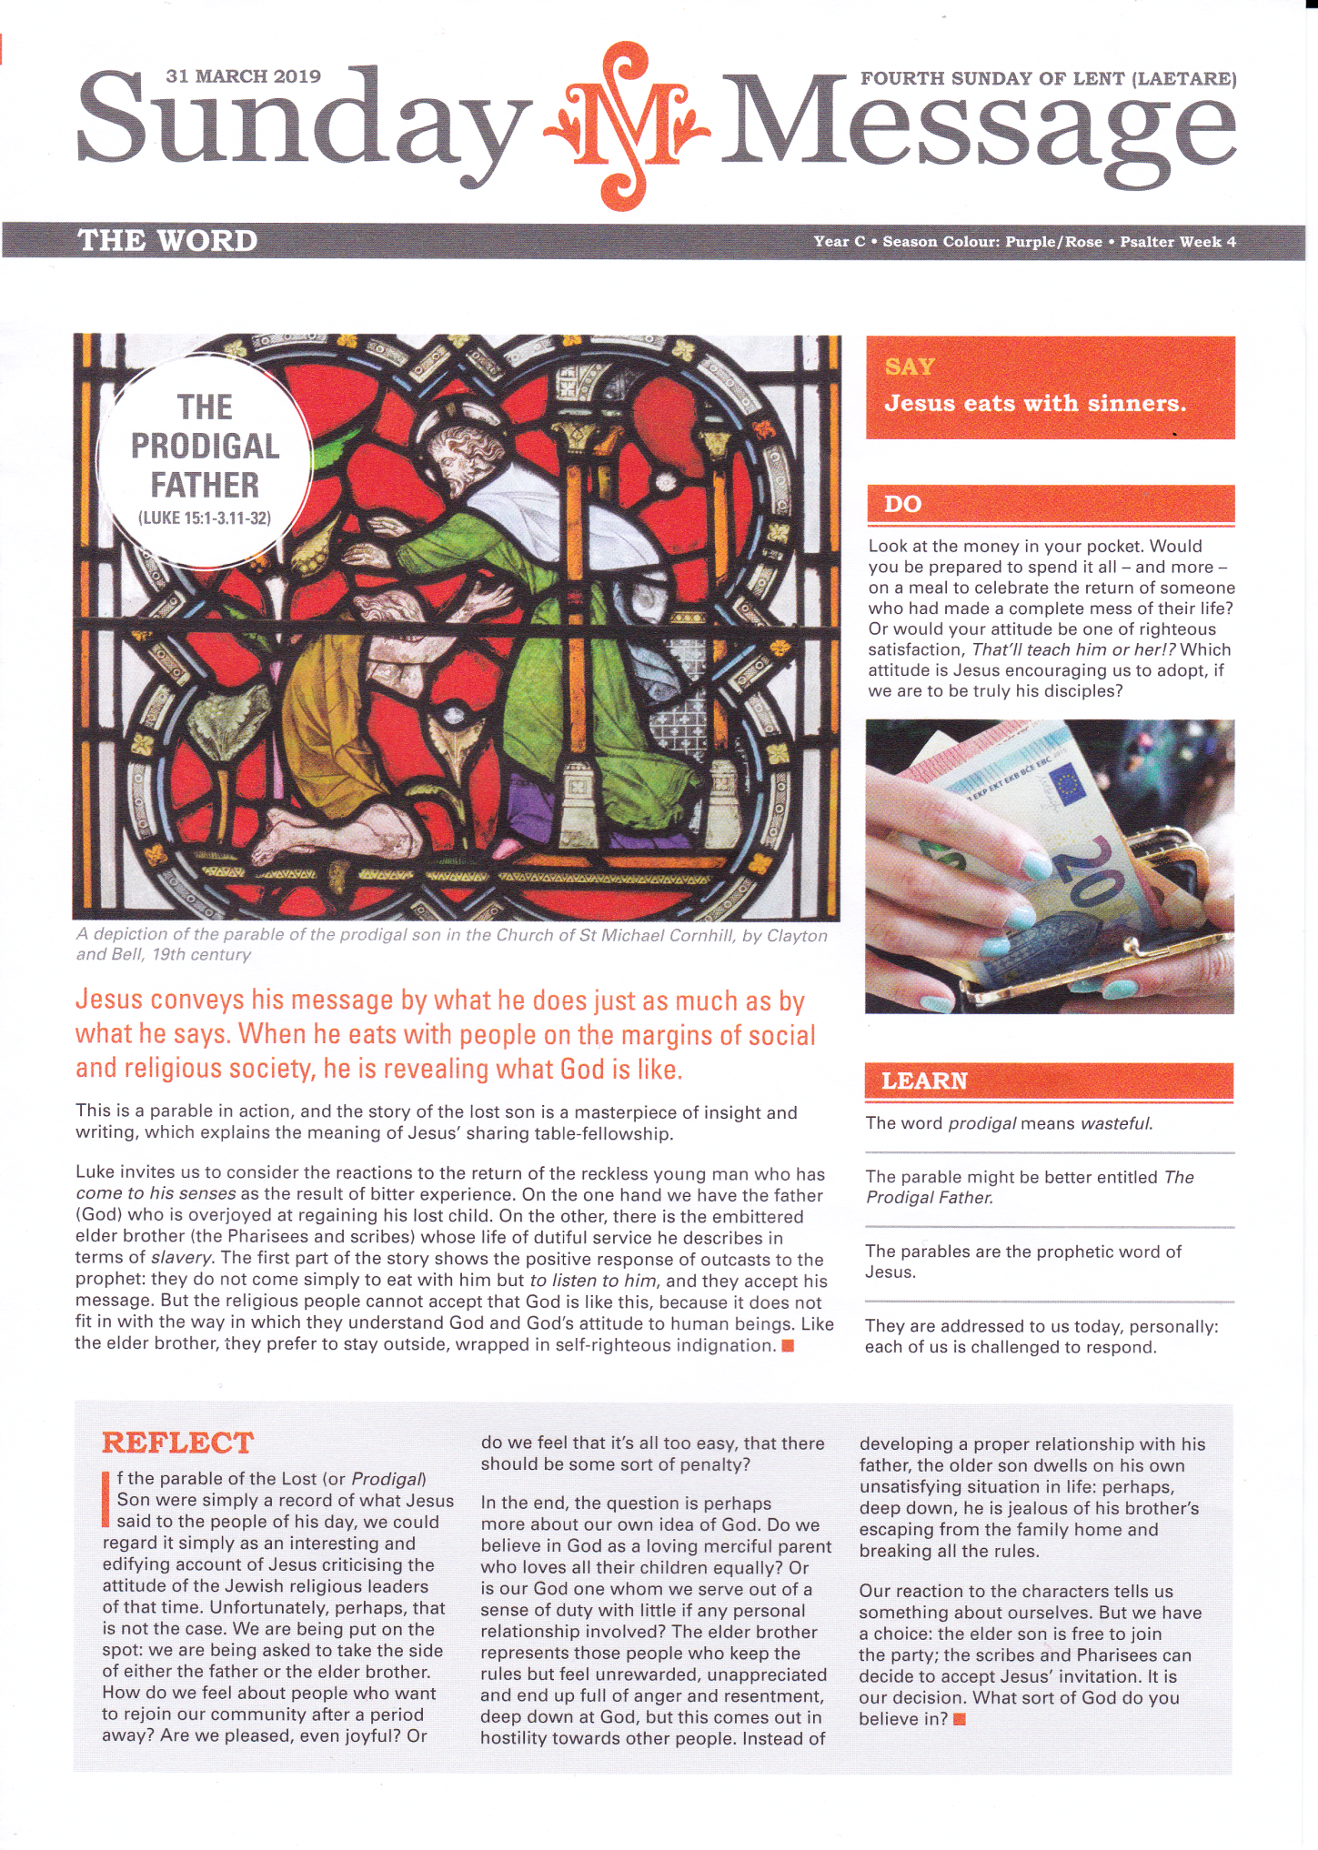

SWINFORD MEELICK MIDFIELD
Fr Dermot Meehan Phone: 094-9251790/Urgent Calls: 087-1338200

PARISH OFFICE- OPENING HOURS: Mon, Thurs, Fri: 9.00am-2.00pm; Phone: 094 - 9253607
Email: swinews@hotmail.com 31st Mar-7th Apr 2019
FOURTH SUNDAY OF LENT
Saturday 30th 6.30pm Swinford: Teresa & Keira Henry, Ballydrum
Jim & Mary McCann, their daughter Margaret & son
Jim & his wife Mary, Kilbride
Sunday 31st 12 noon Swinford: Hubert & Catherine Gallagher & dec’d Family,
Cloonfinaun
Richard & Pat Gallagher, their parents & dec’d
Family, Carrowreagh
Monday 1st 10.00am Swinford: Mass of Thanksgiving
Tuesday 2nd 10.00am Swinford: No Intentions
Wednesday 3rd 10.00am Swinford: Joseph Cummins, Brabazon Heights
(Padre Pio Devotions after Mass)
Thursday 4th 10.00am Swinford: Tom Grifferty, his parents Pat & Kathleen
Friday 5th 10.00am Swinford: Bill & Eileen Ormsby, Park Road
Saturday 6th 10.00am Swinford: Robert McCallion, Park Road
FIFTH SUNDAY OF LENT
Saturday 6th 6.30pm Swinford: Bernadette O’Connor, Larch Hill & dec’d O’Connor
& Hegarty Families
Tony Moore & dec’d Family, Newpark
Sunday 7th 12 noon Swinford: Michael McNulty, Carnacul
Jack & Betsy Campbell, their son Michael, Co. Tyrone
__________________________________________________________________________________
Sunday 31st 9.00am Meelick: Anne & William Murphy, Bothaul & dec’d Murphy,
Killilea & Roche Families
Paddy Philbin, Steeple Village & dec’d Philbin Family
& Tom & Kitty Durkan, Derryronane
Sunday 7th 9.00am Meelick: Peter & Delia Murphy, their son Pete & dec’d
Woodlock Family

Sunday 31st 10.30am Midfield: Mary & John McLoughlin, their daughter Mary,
Woods
Noreen Earley (nee McLoughlin), Mullingar/Kinaffe
Sunday 7th 10.30am Midfield: Mary & James Keane & dec’d Family, Faheens
Michael, Mary & Kathleen Philbin, Tom & Kevin
Basquil, Julia & Pat Gallagher, Curryane, Rose & Jack
Kelly & Ellie, John & Jim Murtagh & dec’d Moran &
Kelly Families
Adoration of the Blessed Sacrament:
Swinford Church: Sundays: 2pm-6pm & Thursdays 10.30am-8pm
Midfield Church: Mondays 11am-12noon
Meelick Church: Mondays 7pm-9pm
__________________________________________________________________________________

Please pray for Monsignor Martin Cassidy, formerly of Brackloon who has died in Florida in the U.S and Kathleen Brennan (nee Byrne), Co.Kildare and formerly of Woods, Midfield. May they rest in the peace of Christ.
We welcome into the Christian community Arthur Michael Richard Ball-Ryan, Tumgesh who was baptised recently in Swinford Church.
Parish Pastoral Council: The April meeting of the Parish Pastoral Council will take place in the Meeting Room in the Parochial House on Monday, April 1st at 8.00p.m.
Confirmation: The Sacrament of Confirmation will take place in Swinford Church on Sunday 12th May at 1.30pm for all schools of our parish.
Join Accord Charlestown: Accord Charlestown is inviting applicants to act as Facilitators in Marriage Preparation courses. Anyone interested in becoming a Facilitator should contact Accord Charlestown on 094-9254944 or email accordcharlestown@gmail.com before 12th April.
Organ Donor Awareness Week 2019: To mark Organ Donor Awareness week 2019, Mass will take place in the Knock Basilica on Sunday 7th April at 12 noon in Solidarity with those who are waiting for or have received organs and in thanksgiving for those who have donated organs. It will also remember all those who have died and whose organs were donated by their families. All are welcome.
First Saturday Devotions is being hosted in Knock Old Parish Church on Saturday April 6th starting at 11.00am with Rosary, Meditations and concludes with Holy Mass at 12.00 noon, Confessions and Enrolment of the free brown scapulars. All are welcome.
Swinford GAA: A fundraising table quiz will take place in Mellett's Emporium on Friday 5th April at 9pm. Tables of 4 €40.
Swinford Comhaltas Spring Show: Michael Davitt CCE are hosting the Connacht Fleadh Cheoil in Swinford from July 1st-7th and as part of our preparations, we will be presenting a Spring Show – “Anois teacht an Earraigh” in the Cultural Centre on Saturday April 13th at 8.00pm. The show will be a feast of music, song, dance and storytelling and the theme will be based on the traditions, customs and stories associated with the seasonal activities of spring and the various feast days from St Stephen’s Day up to May Day. Featuring a host of local and visiting talent this will be a very enjoyable night.
Swinford & District Club will be taking a day trip to Loughrea on Saturday 4th May. Included is a visit to Woodville house and guided tour of walled gardens, Dartfield Horse Museum and Loughrea Cathedral. Breakfast and dinner included. Cost €65. Contact Angela on 087-7917136 for more details.
Western Alzheimers is in the process of setting up a new voluntary befriending service in Mayo, to accompany people living in the early stages of dementia. Full training provided. A meeting will take place in the TF Royal Hotel in Castlebar on Friday April 5th from 11-1pm, to explain about this service. All are welcome.
Chiropodist: Martin McNally will attend at The Gateway Hotel, Swinford on Friday 5th April from 10.00am.
Swinford Agriculture Show: Fundraising 25 Card Game takes place in the Gateway Hotel, Swinford on Sunday 31st March at 8.30pm. Your support is greatly appreciated.
Western Alzheimers Annual Tea Day is Friday 12th April, Phone 094-9364900 to register and get a tea day pack. We depend heavily on income from fundraising to maintain and expand our range of supports and services. Our biggest fundraiser is our annual Tea Day. Please host or support a local tea day.
Swinford Golf/Soccer 250 Draw: Results from Draw No.1 which was held on 17th March.
€1000 was won by Bobby Brennan, Midfield
€300 was won by Tom Bardwell & Shane Lacey, Swinford.
€200 was won by Stephen Kenny, Dublin Road
All results available on our websites.
Swinford Community Lotto: Results for 25th March Numbers 01 14 15 26; €70 Local Shopping Voucher Winners: Olga Connolly , Monaghan; Eileen Duffy, Johnsfort; 3 Number Winners: Josie Higgins, c/o Melletts; Geraldine O’ Connor, c/o Horkans ; Jackpot €11,000 Next draw on Monday 1st April.
Mayo North East is organising a free Healthcare Support Training Course QQI Level 5 major Award in Swinford for unemployed people or people in part-time employment. Contact Dolores McNicholas on 087-7704251 for more information.

